Tutorial - 7
Five-Number Summary and Box Plots
In the world of Machine Learning and Data Science, identifying extreme or unusual data points—known as Outliers—is a critical skill. These outliers can lead to problematic models if not handled correctly. Today, we will learn how to use the Five-Number Summary to mathematically detect these outliers and visualize them using a Box Plot.

1. What is the Five-Number Summary?
The Five-Number Summary provides a snapshot of your data's distribution. It consists of five key values:
- Minimum: The smallest value in your dataset (excluding outliers).
- First Quartile ($Q1$): The 25th percentile of your data.
- Median ($Q2$): The exact middle value (50th percentile).
- Third Quartile ($Q3$): The 75th percentile of your data.
- Maximum: The largest value in your dataset (excluding outliers).

2. Detecting Outliers: The "Fence" Technique
To mathematically decide if a value like 27 in your dataset is an outlier, we calculate boundaries called Fences.
The Formulae
$$IQR=Q3-Q1$$
$$Lower Fence=Q1-1.5×IQR$$
$$Upper Fence=Q3+1.5×IQR$$
Definition of an Outlier: Any data point that falls below the Lower Fence or above the Upper Fence is officially considered an Outlier.

3. Step-by-Step Example
Dataset ($n=19$):
$$\left\{1 , 2 , 2 , 2 , 3 , 3 , 4 , 5 , 5 , 5 , 6 , 6 , 6 , 6 , 7 , 8 , 8 , 9 , 27\right\}$$

Step 1: Find $Q1$and $Q3$
Using the percentile formula:
$$Index=\frac{Percentile}{100}×(n+1)$$
- $Q1$(25th Percentile):
Index is
$$\frac{25}{100}×20=5^{th}\text{ position}$$
The 5th value is 3.
- $Q3$(75th Percentile):
Index is
$$\frac{75}{100}×20={15}^{th}\text{ position}$$
The 15th value is 7.

Step 2: Calculate $IQR$and Fences
- $IQR$:
$$7-3=4$$
- Lower Fence:
$$3-(1.5×4)=3-6=-3$$
- Upper Fence:
$$7+(1.5×4)=7+6=13$$

Result:
Our "normal" range is $-3$to $13$. Since 27 is greater than 13, it is confirmed as an Outlier.

4. The Box Plot (Whisker Plot)
A Box Plot is the visual version of the Five-Number Summary. It helps you see where your data is centered and where the outliers are hiding.

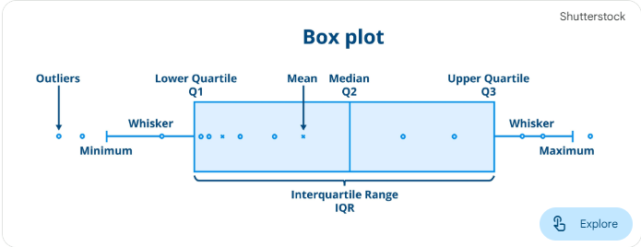
- The Box: Represents the middle 50% of your data (from $Q1$to $Q3$).
- The Median Line: A line inside the box showing the center ($5$).
- The Whiskers: Lines extending to the Minimum ($1$) and Maximum ($9$) within the fences.
- The Dot: Any point (like 27) plotted outside the whiskers is an outlier.

5. Final Revision Summary
- Five-Number Summary includes Minimum, $Q1$, Median, $Q3$, and Maximum.
- $IQR$is the distance between the 75th and 25th percentiles.
- Outliers are detected using Lower and Upper Fences.
- Box Plots are the best visual tools for EDA (Exploratory Data Analysis) to spot errors and extreme values in a dataset.

Teacher's Tip:
In tools like Python's Seaborn or Matplotlib, a simple command can generate this plot and instantly show you the "dots" that represent your outliers!

